Multiplayer Game Programming Assignment 2

Features + Description:

1: Maximum player limit of 3

The maximum numbers of players are 3, when the 4th player tries to connect, there will be a message that says that the server is full and the player can only quit the game.

Client(application.cpp)

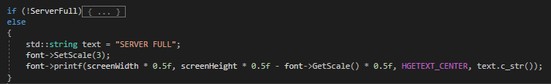

ServerFull is a Boolean that will be set to true if the server returns a message that says it is full when the player tries to connect.

Server(process_received_packet.cpp)

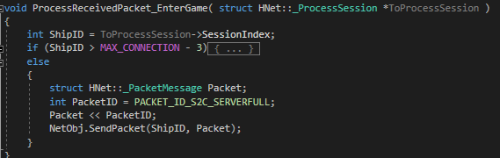

This will detect if the server is full when the player tries to connect and send a server full message to the player if the server is full.

2: Dead Reckoning

Position pos_server and pos_client has been added to movables to implement interpolation and extrapolation for those objects that move and collide. All movement related codes such as collision, velocity transfer and update has also been edited to use server values instead of client values to implement interpolation and extrapolation.

Client:

All objects.cpp, movables.h and movables.cpp, movement and collided functions in send and receive packet.cpp and .h, application.cpp velocityTransfer and checkCollided functions.

Server:

movement and collided functions in send and receive packet.cpp and .h.

3: Asteroids (server controlled)

The asteroids are server-controlled objects that move around and can collide with player ships.

Client:

Asteroid.cpp and .h, asteroidMovement and collision send packet and receive packet in send and receive packet.cpp and .h.

Server:

Asteroid.cpp and .h, main.cpp movement updates, VelocityTransfer_AsteroidAndSpaceship and hasCollidedAsteroid functions.

4: Missile do damage to ships

Missiles will do 1 damage to an enemy ship if hit.

Client (Process_received_packet.cpp)

Function: ProcessReceivedPacket_MissileCollided

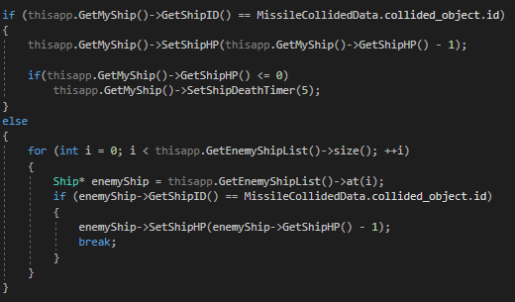

5: Boom effect is rendered and synced through the network

Boom effect will be rendered when a missile collides with something.

Client (Process_received_packet.cpp)

Function: ProcessReceivedPacket_MissileCollided

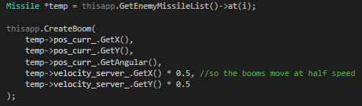

6: Spaceship Hp

I added a int hp to the ship and set the maximum spaceship hp to be 5. Getting hit by enemy missile, colliding with asteroids and enemy ships will deal -1 hp and timebombs (will explain later in the document) will deal -2hp if hit.

Client:

Ship.h and .cpp, process_received_packets.cpp (functions that have collision involved and ProcessReceivedPacket_TimebombTimer), process_send_packets.cpp (to send the hp to the server and sync through the clients).

Server:

Process_received_packets.cpp and process_send_packets.cpp to take and pass in the ship hp.

What it looks like in game:

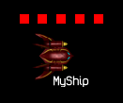

7: Ship is destroyable

If the hp reaches 0, the ship is destroyed and cannot move anymore. Collision will also not go through.

Client: application.cpp

Update and Render functions.



8: Respawning for ships

When the client’s ship is destroyed, a respawn timer will pop up and countdown, telling the player how long it takes to respawn the ship. I set the current respawn timer to 5 seconds. The player will then respawn in a random location in the map.

Client (application.cpp)

Update function

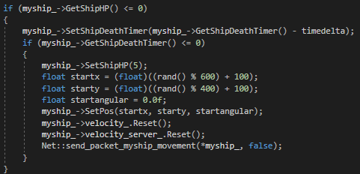

Render function

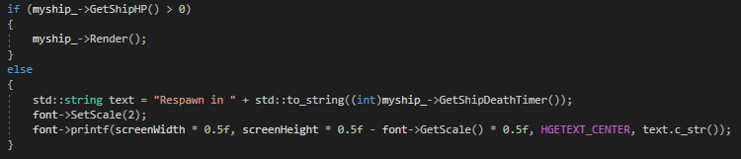

9: Timebomb

The player can press B to put down a timebomb in his/her current location. The timebomb will explode after 3 seconds and damage any enemy ship that is in the area. The countdown timer is managed by the server to ensure it continues running if the client lags/crashes.

Client:

Explosion.cpp and .h, Timebomb.cpp and .h,

Process_received_packet.cpp

(ProcessReceivedPacket_NewTimebomb() & ProcessReceivedPacket_TimebombTimer)

Process_send_packet.cpp

send_packet_new_timebomb()

application.cpp

Update function

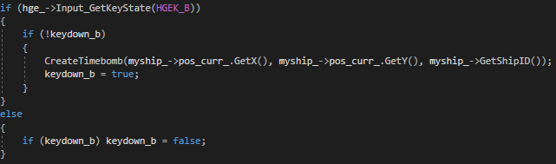

And CreateTimebomb + CreateExplosion function.

Server:

Timebomb.h and .cpp,

Main.cpp (timebomb list + updating the countdown)

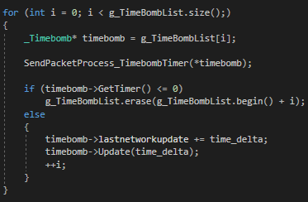

Process_received_packet.cpp

ProcessReceivedPacket_NewTimebomb()

Process_send_packet.cpp

SendPacketProcess_TimebombTimer()

What it looks like in game:



Explosion:



10: Med Kits (aka health packs)

Health packs are also server-controlled objects. One will spawn every 5seconds if one doesn’t already exist in the map. Ships that take the health pack will be instantly healed to full health.

Client:

Medkit.cpp and .h

Process_received_packet.cpp

ProcessReceivedPacket_NewMedkit()

ProcessReceivedPacket_MedkitTaken()

Process_send_packet.cpp

send_packet_medKit_taken()

Server:

Medkit.cpp and .h

Main.cpp (spawning of medkit)

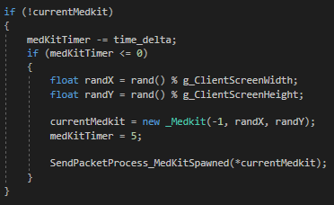

Process_received_packet.cpp

ProcessReceivedPacket_MedkitTaken()

Process_send_packet.cpp

SendPacketProcess_MedKitSpawned()

What it looks like:

